Q1. Write a java program to print even number from10 to 20.

10

12

14

16

18

20

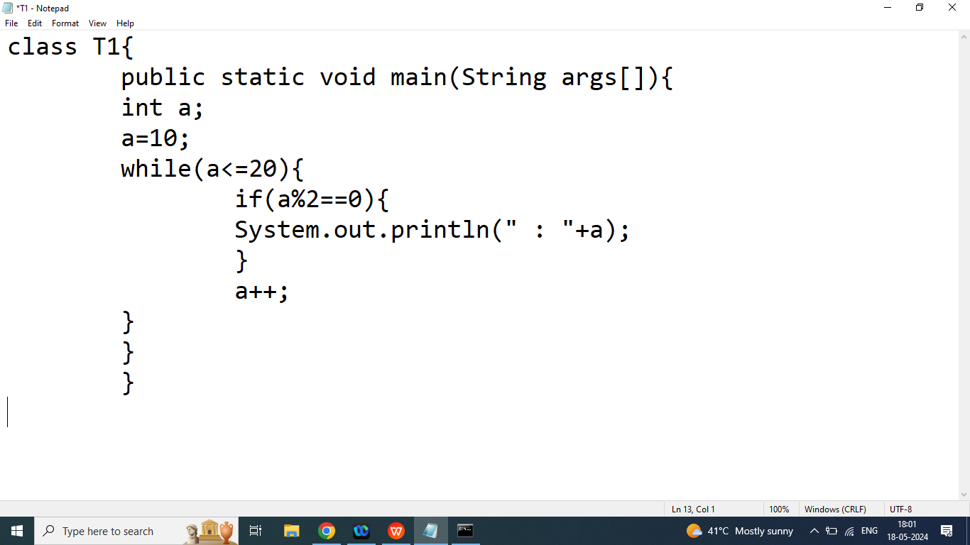

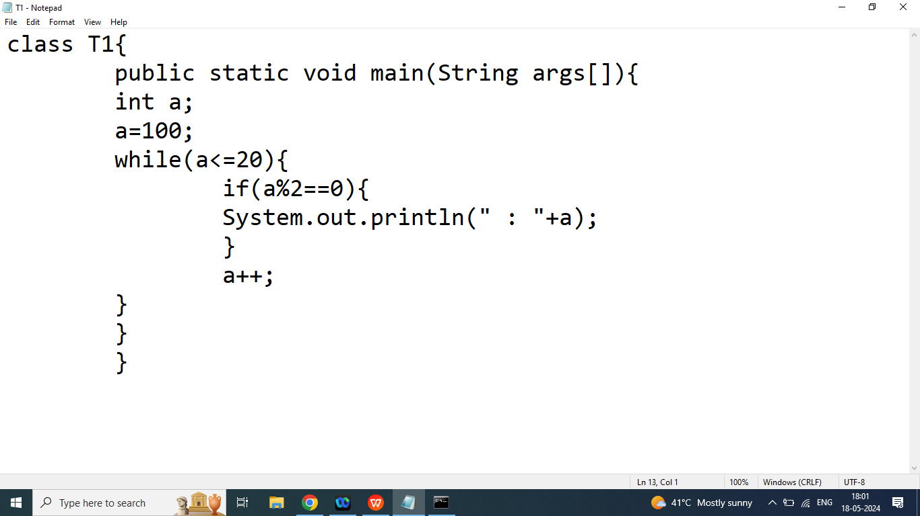

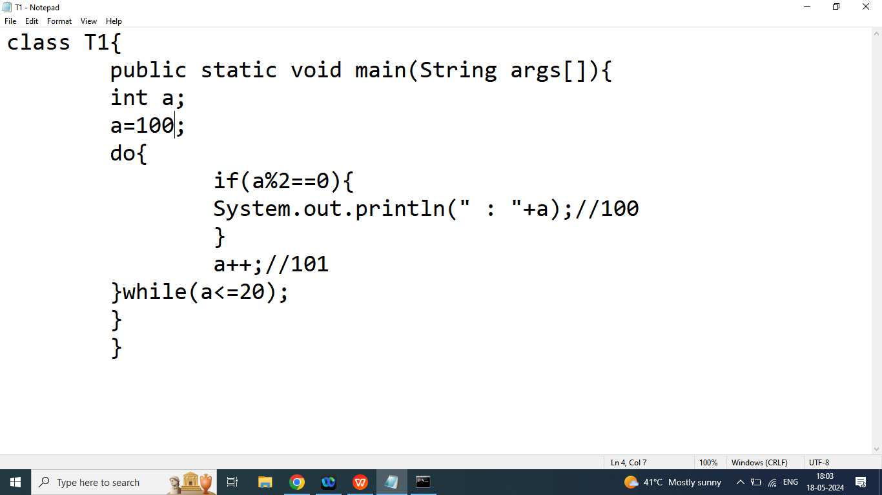

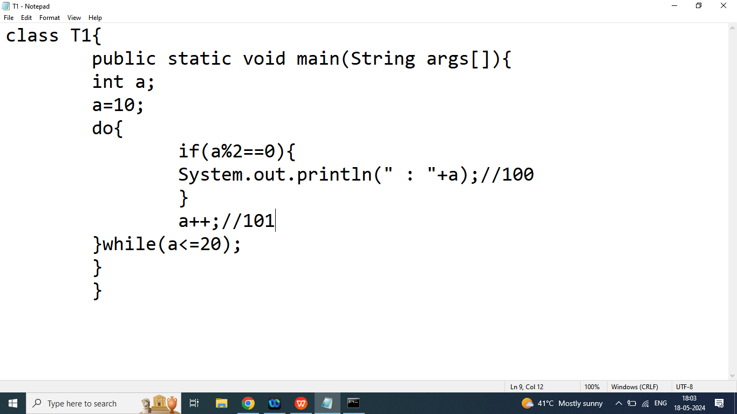

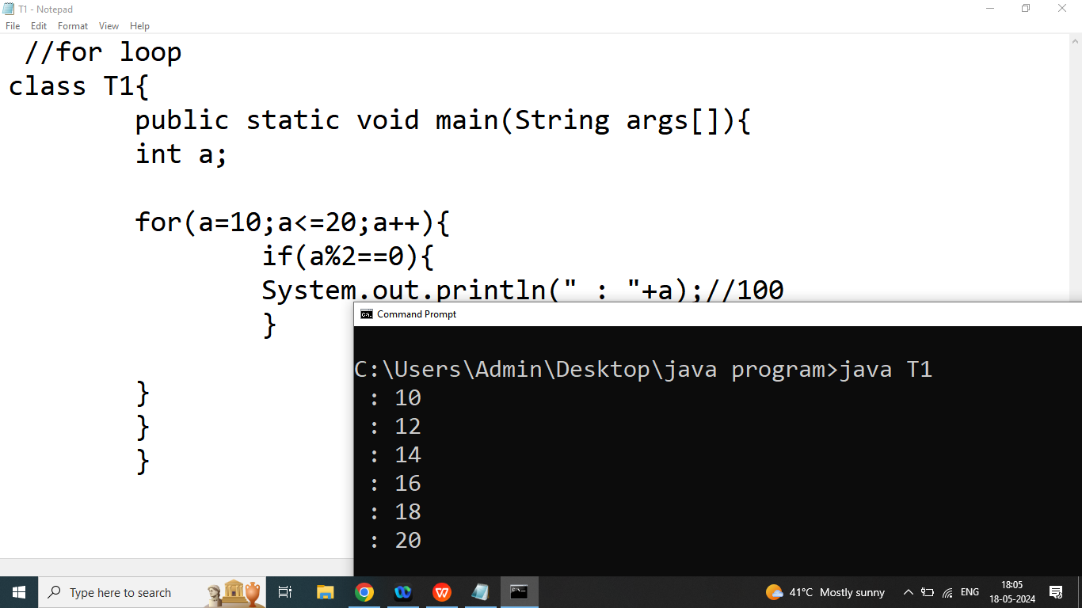

Q2. Write a java program to print table of given Number

Enter Any Number : 2

2

4

6

8

10

12

14

16

18

20

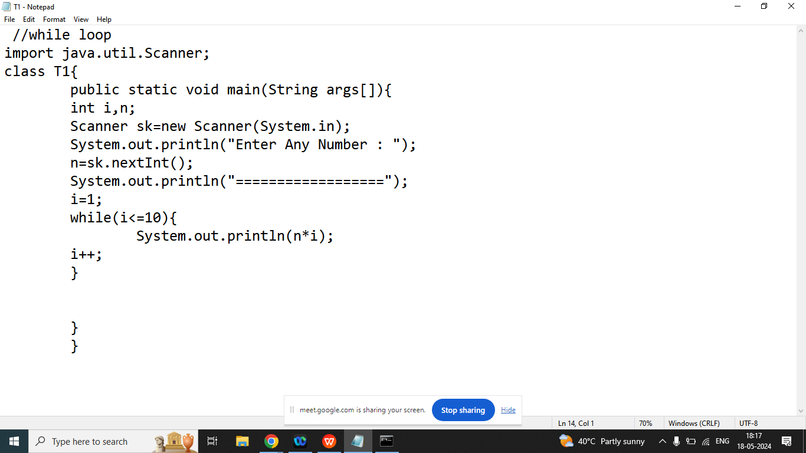

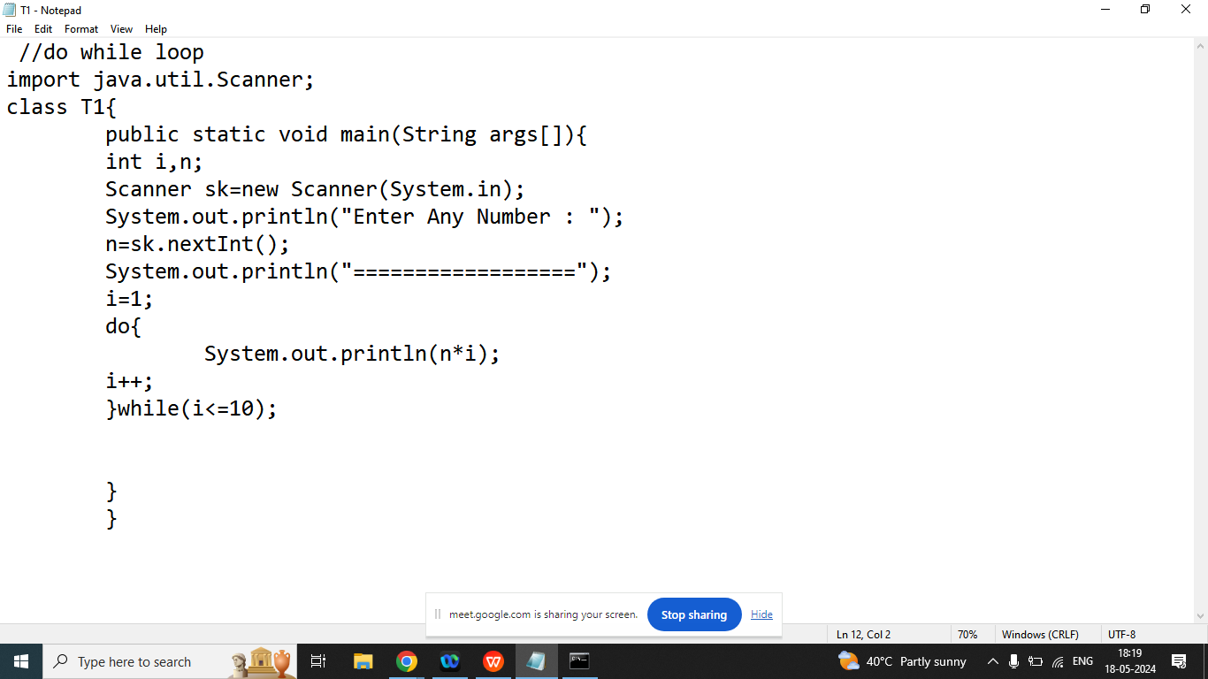

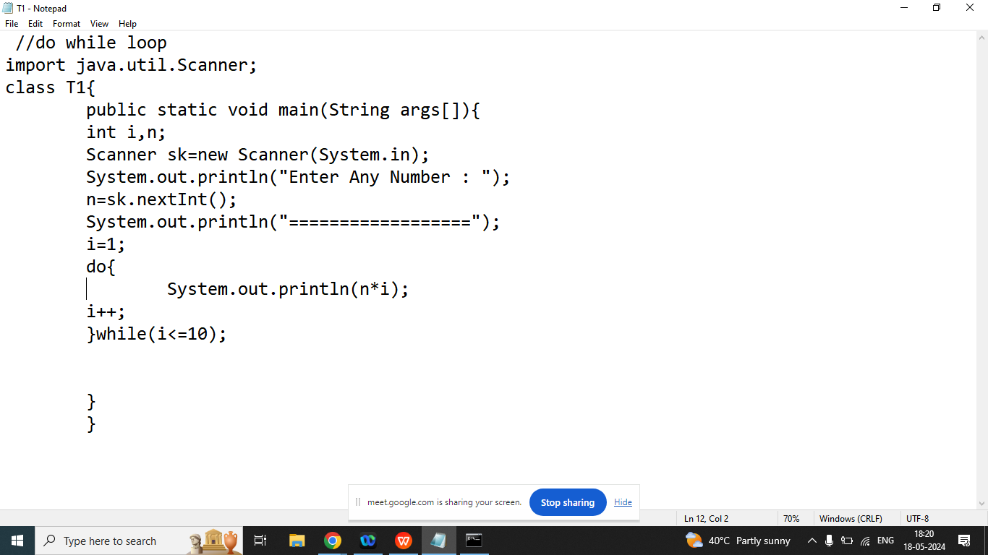

Q3. Write a java program to print Number from 50 to 100 which is divisible by 5 using while, do while, for loop?

50

55

60

65

70

75

80

85

90

95

100